Jeremy Greenwood: ID #000917613
Instructor Jim Ashe
Mentor Rebekah McBride
C951 - NIP1 Task 1: Chatbot

PRETEXT

The scenario identifies two goals for the chatbot:
- reduce the workload of the career advisor
- interact with students to help them identify jobs in computing fields for which they are qualified

Let us start with the second goal. We can begin by eliminating jobs for which the students are not qualified. Several of our state universities offer robust Computer Engineering programs that run parallel with their Computer Science programs. Coupled with the fact that the university in the scenario “offers many degrees,” we can eliminate those careers which are primarily hardware-focused due to lack of qualification. Consequently, we can achieve the second goal by associating relevant program electives with career titles, and providing descriptions of those jobs:
CSE 4153 – Data Communications and Computer Networks → Network Administrator
CSE 4163 – Designing Parallel Algorithms → Data Analyst
CSE 4253 – Secure Software Engineering → Software Developer
CSE 4633 – Information Architecture → Database Administrator
CSE 4743 – Operating Systems II → Systems Programmer

The remaining goal is more difficult to quantify. In our scenario, the position of Career Advisor is more of a human resources role than instructional. It has been suggested that (Carter and Knol, 2017):

1. Future incarnations of HR may be very different than they are now: removing the human element entirely
2. Chatbots are not capable of operating on their own and will require humans to assist

Given this, we can consider our project solution as an assistive measure. We will not be able to eliminate the need for meeting with a Career Advisor. Instead, we can use the chatbot to increase the efficiency of the meetings which do occur. This can be achieved by increasing the likelihood of the students being better informed of potential careers prior to attending the meetings. Ideally, this would lead to more informed student questions and require less time per interaction.

BUILDING THE CHATBOT

When I began developing this project, I was prompted for a name by pandorabots.com's setup wizard. With minimal thought, I named it Maggie. Parmy Olson at Forbes.com points out an interesting trend, quoting AI-engineer Seth Juarez, of labeling service-based chatbots with female names and intelligence-based chatbots with male names (Olson, 2019). Being strongly in favor of gender equality in the workplace, I later decided to name my chatbot Monty instead.
After reading thoughts on the potential downsides of using chatbots in the hospitality industry, I decided to limit the level of detail I would pursue in optimization (Michiels, 2017). Since there exists the possibility that log data could be stored in an unsecured environment, I wanted to discourage the user from entering personal information.

I started by constructing a script made of simple keyword prompts mapped to a set of occupations. Given the simplistic nature of the scenario, my chatbot would be classified as a reflex agent.
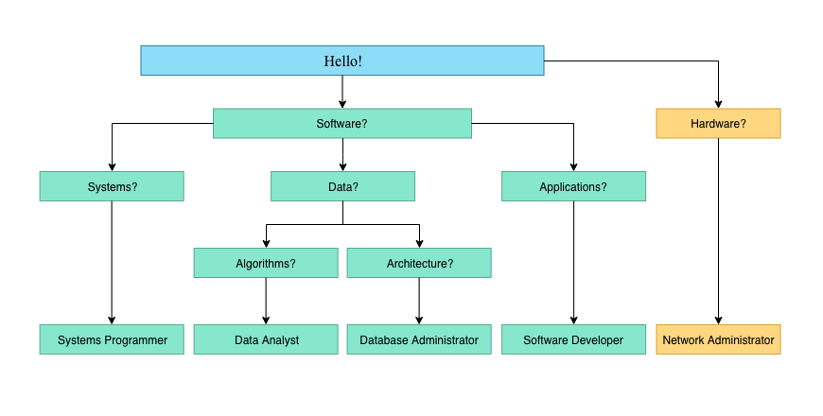
Initial optimization involved creating a response table and strictly limiting the responses to that table, consistent with a typical reflex agent. The interaction was developed in a one-shot manner: if a student answers the question, they receive a single response and the process moves forward without storing state. Given the small size of the project, this was not an issue. If the user typed in a valid alternative response for a prior prompt, the other responses would still be available and returned by the bot.

Next, I proceeded to train the bot by querying it with larger and more varied inputs. I attempted to select training cases using natural language. Being the only person interacting with the bot, I became the primary limiting factor during this section. I decided that stating an occupation at the end of the interaction would be insufficient to meet the project's goals. In response, I placed a brief description of the occupation with the name. I later added a brief suggestion to enroll in the correlated elective, e.g.

Initial:
Data Analysts work to glean meaningful, business insights from large stores of data.
Expanded:
You might consider enrolling in CSE 4163 – Designing Parallel Algorithms.

Further optimization is best suited to occur after the application has been in production for some length of time and sufficient log data has been obtained. This log data could then be used to train the chatbot: use similar queries to generate synonyms and symbolic reductions, identify unique queries that could indicate possible need to reformulate prompts or potential to explore new functionality, etc.

CONSIDERATIONS

The primary challenge in developing this bot was dealing with the limited nature of using a reflex agent. On one hand, if another response becomes necessary, it is a simple matter to add it to the response table. On the other hand, if it becomes necessary to modify or delete a response, digging through those casual additions can quickly become problematic. I resolved this conflict by assembling the user prompts into a set file (prompts.set). I then created a map file (responses.map) of those prompts with their appropriate responses. This ensures that, should the need arise, I am able to quickly modify a response or add a prompt by visiting two files.

One principle strength to this bot environment is that its observability is complete. All components of the exchange occur through a text interface and are recorded. Valid and invalid responses are all retained. While an appropriate response is not guaranteed to be available immediately, it can be generated post hoc.

One obvious weakness of this bot environment involves the stochastic nature of the user responses. An example: I wanted to be able to parse substrings from the user response to determine if it contained a valid keyword found in my response table. Logically, the keyword could have text before it, after it, both, or neither. Using the wildcard operators, I was only able to account for 2 of the 4 conditions. The problem comes when the keyword is preceded by any other input. In order to locate the keyword, the exact preceding input or its character length must be known. Obviously, this is difficult to achieve. I experimented with using a loop to iterate through all of the space delimited words within the input string. Unfortunately, I have been unable to get this to function adequately.

INSTALLATION

Pandorabots is designed to be embedded within a larger web application, e.g. as part of a web page, single page application, smartphone app, etc. To do so requires the application to run over an internet connection and requires the purchase of a developer key. As such, an actual installation is beyond the scope of this project. However, it is still possible to utilize my project files and experiment with the project.

- Create an account at home.pandorabots.com and sign in
- In the left hand menu, at the end of MY BOTS, click the '+'
- Enter a name in the name field and click Create Bot
- In the left menu, expand the Edit submenu
- Select Code Editor
- Select File → New → AIML
- Enter main and click Create File
- In a new browser tab, open https://github.com/jgreenwd/Monty/blob/master/main.aiml
- Copy all 45 lines to the clipboard
- Paste the contents to the main.aiml tab
- Select File → Save
7. Repeat the process for these files:
- File → New → Maps (https://github.com/jgreenwd/Monty/blob/master/responses.map)
- File → New → Sets (https://github.com/jgreenwd/Monty/blob/master/prompts.set)

The chatbot is now ready to interact. In the bottom right-hand corner of the browser window, click the circle icon. This will activate the chatbot. Begin interaction by entering 'hello' at the message prompt.

BIBLIOGRAPHY

Carter, Emma & Knol, Charlotte. (2019). “Chatbots — an Organization’s Friend or Foe?”, Research in Hospitality Management, 9:2, 113-116. DOI: 10.1080/22243534.2019.1689700

Michiels, E. (2017). Modelling chatbots with a cognitive system allows for a differentiating user experience. PoEM 2017 Doctoral Consortium and Industry Track Papers, 2027, 70–78. Retrieved from http://ceur-ws.org/Vol-2027/

Olson, Parmy. “Banks Are Promoting 'Female' Chatbots to Help Customers, Raising Concerns of Stereotyping.” Forbes.com, Feb. 27, 2019. EBSCOHost, Link. Accessed Feb. 11, 2020.

